ATACseq Analysis  
Kfir Inbal, Bioinformatician, Madi Lab

Step 1 – QC, Alignment & Peak Calling (Shell Environment)

The original ".bam" files were first converted into FASTQ format for quality analysis using FastQC [1]. The FASTQ files underwent quality refinement with Trimmomatic [2] and Repair.sh from BBMap [3]. The repair script was used to ensure that paired-end reads are correctly matched, removing any mismatches and generating fixed FASTQ files for subsequent analysis. Alignment to the Hg38 reference genome was performed using BWA-MEM [4]. Post-alignment, no duplicates were detected. Mitochondrial chromosomes and blacklist regions were removed to reduce noise and bias, and read coordinates were shifted to account for Tn5 transposase insertion using alignment sieve [5]. Peak calling was performed with MACS2 [6], and footprinting analysis was conducted using TOBIAS [7].

Step 2 – Metadata

A metadata file, Sample_Sheet_All.csv, was created to categorize the samples into four groups: CD4_Good, CD4_Poor, CD8_Good, and CD8_Poor, based on the general metadata from the experiment (2024-04-26 Sample info ATAC.xlsx). This categorization was necessary for the subsequent differential analysis and comparisons in R.

Step 3 – Bulk Categorization for TOBIAS (Shell Environment)

The aligned and filtered ".bam" files were merged using Samtools [11] because TOBIAS analysis requires a single aggregated BAM file for each experimental group. Since TOBIAS cannot process multiple individual BAM files together for group comparisons, merging ensures that each group (e.g., CD4_Good, CD4_Poor, CD8_Good, CD8_Poor) is represented by one combined BAM file. This aggregation is essential for accurate analysis and comparison, as it consolidates data from multiple samples into a single file per group.

Step 4 – TOBIAS (Shell Environment)

As mentioned, the aligned and filtered BAM files were organized into groups: CD4 (Good and Poor) and CD8 (Good and Poor). The BAM files for each group were merged into single files to facilitate bulk comparison between Good and Poor categories. TOBIAS functions were then applied: ATACorrect to generate single basepair cutsite tracks, ScoreBigWig to compute continuous footprinting scores across regions, and BINDetect to assess differential binding of transcription factors between the groups. For the BINDetect comparison, peak files from the Good and Poor groups were combined to consolidate the peak data into a single dataset. Additionally, the JASPAR 2024 core non-redundant database of transcription factors [8] was used. Following the BINDetect analysis, a volcano plot was generated to visualize the results, with significant genes defined as those with p-values < 0.05 and logFC > -log(0.9) or < log(0.9).

To strengthen the comparison, we intersected the differentially expressed (DE) transcription factors (TFs) identified from TOBIAS BINDetect results with those from the R DiffBind [9] analysis. TFs that were commonly found in both analyses with the same fold-change direction were filtered based on a threshold of -log(0.9) in the fold change from either DiffBind or TOBIAS BINDetect results. Selected TFs, including POU1F1 (Up_Good), GLIS1 (Up_Poor), POU4F3 (Up_Good), and VEZF1 (Up_Poor), were chosen for the footprinting "aggregate" plot across all sites. This type of plot visualizes the aggregate footprinting signal across a set of genomic regions, such as transcription factor binding sites, providing a summary view of the footprinting data across multiple samples or conditions. Same TFs were also visualized as a heatmap using TOBIAS PlotHeatmap function.

Results

CD4 Good vs Poor

Differentially Bound Motifs Volcano Plot

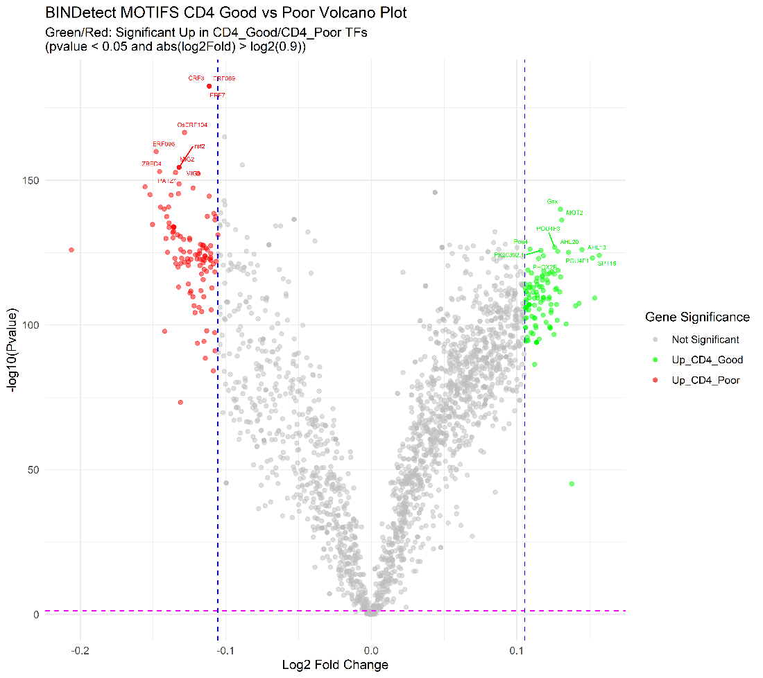

Aggregated Footprinting Plots And Heatmaps

**CD4 Up_Good:**Aggregate Plots

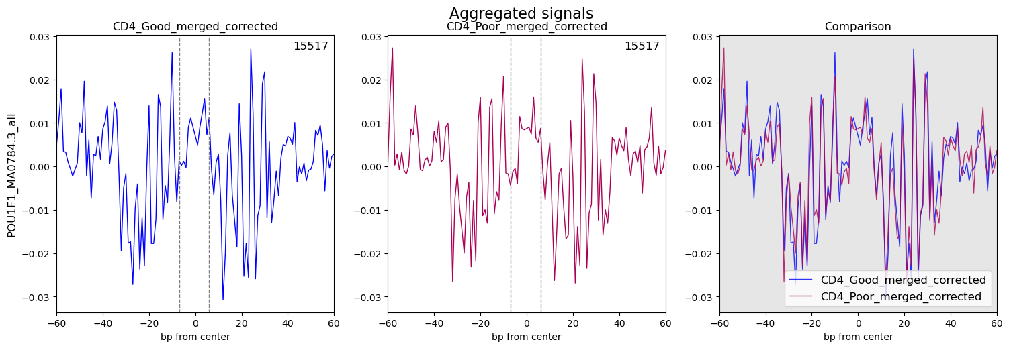POU1F1 –

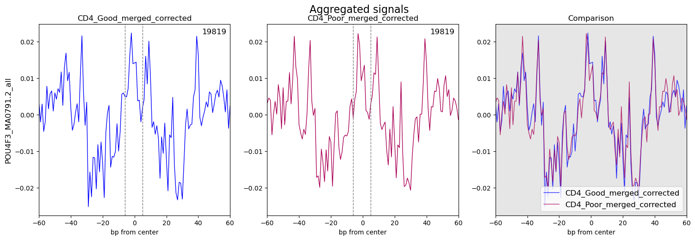POU4F3 –

**CD4 Up_Poor:**

GLIS1 – 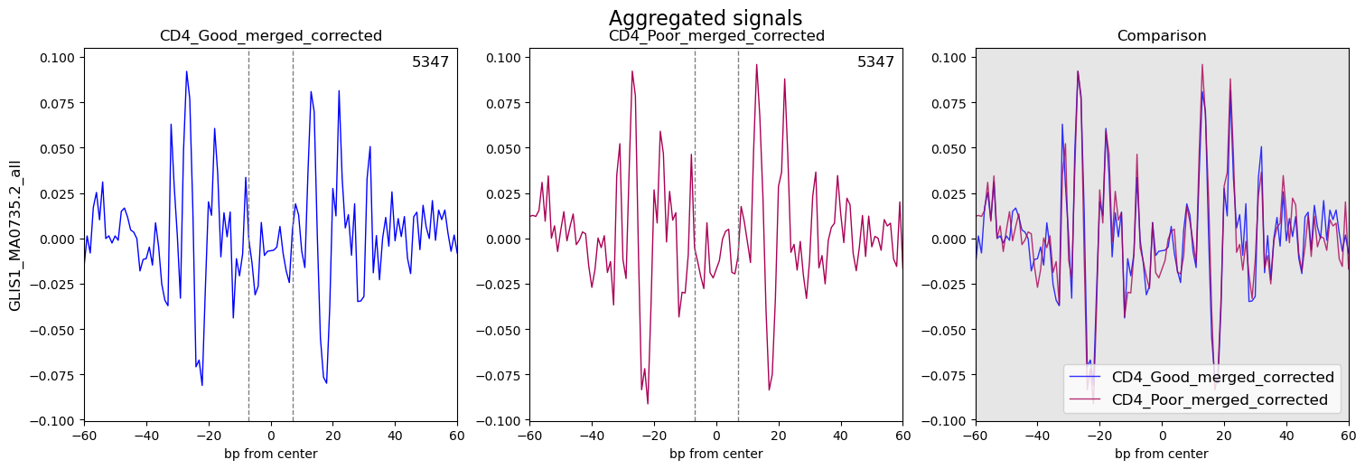

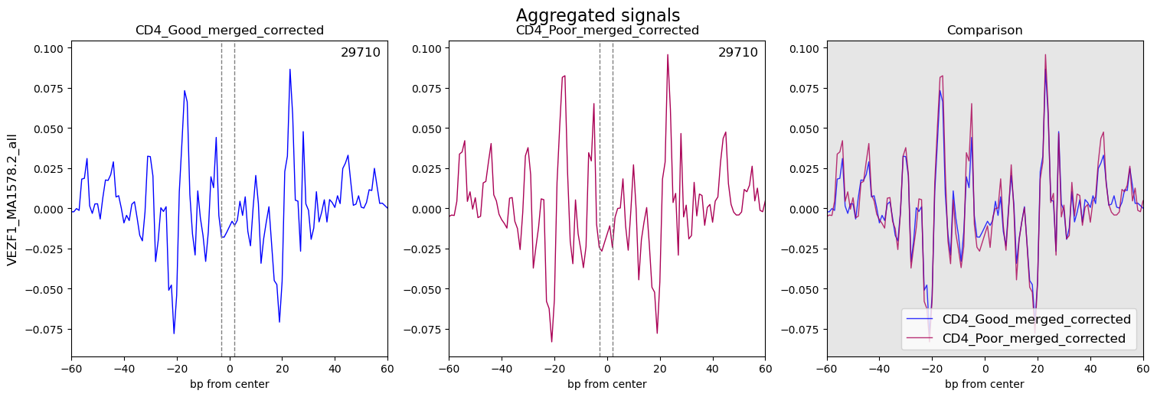VEZF1 –

Heatmaps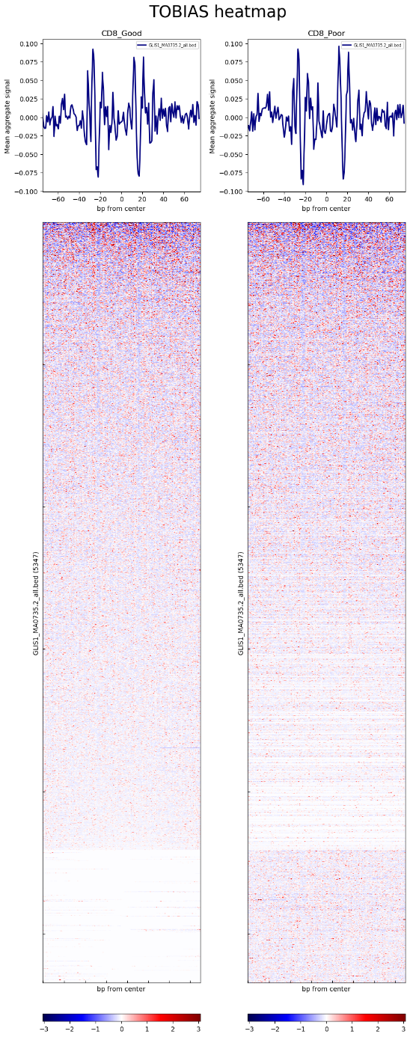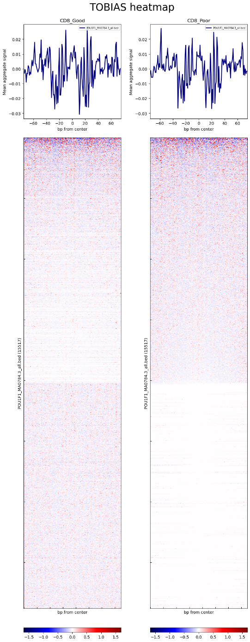

CD8 Good vs Poor

Differentially Bound Motifs Volcano Plot

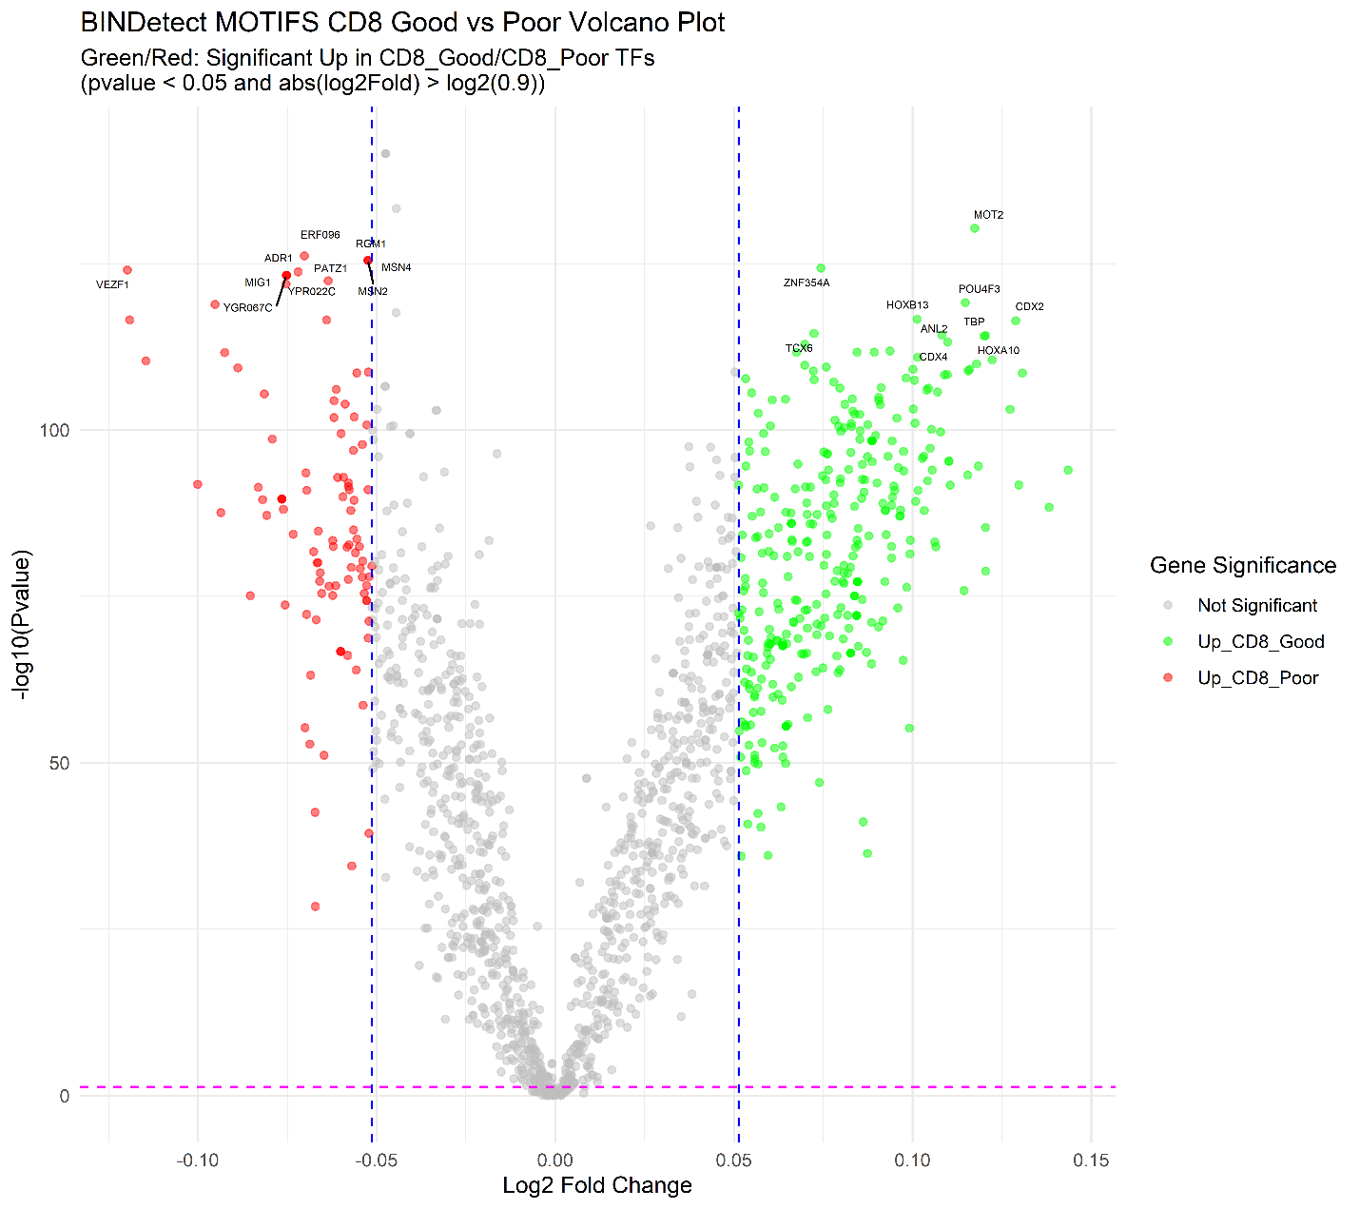

Aggregated Footprinting Plots And Heatmaps

**CD8_Up_Good:**Aggregate Plots

POU4F3 –

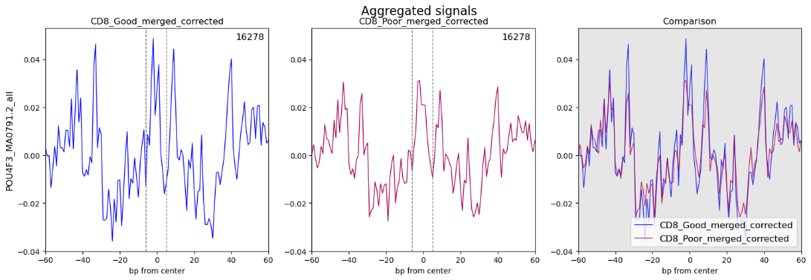

MOEX1 –

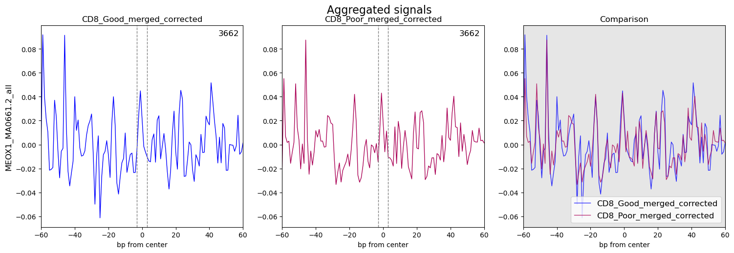

**CD8_Up_Poor:**

VEZF1 – 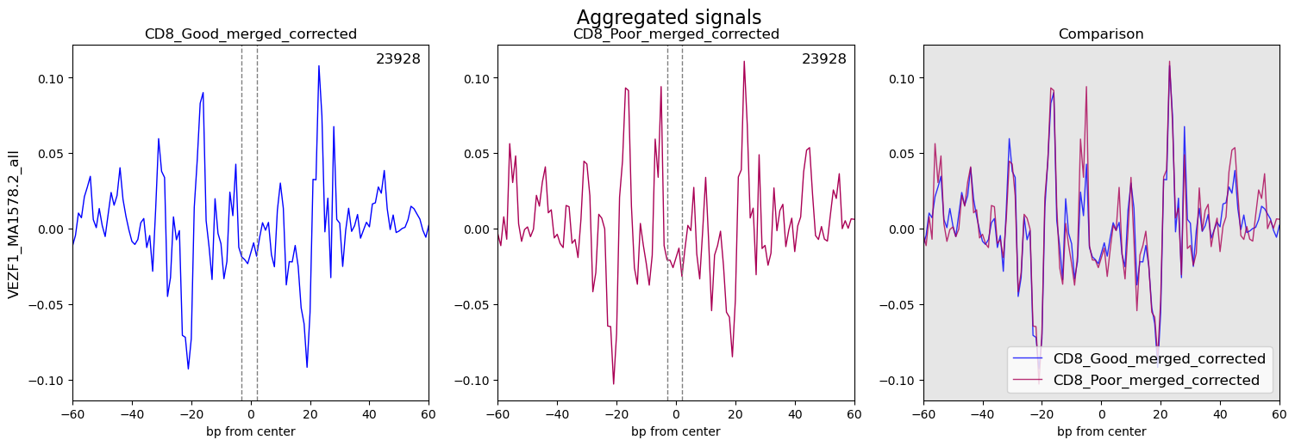

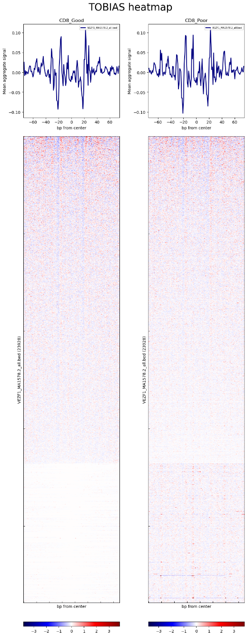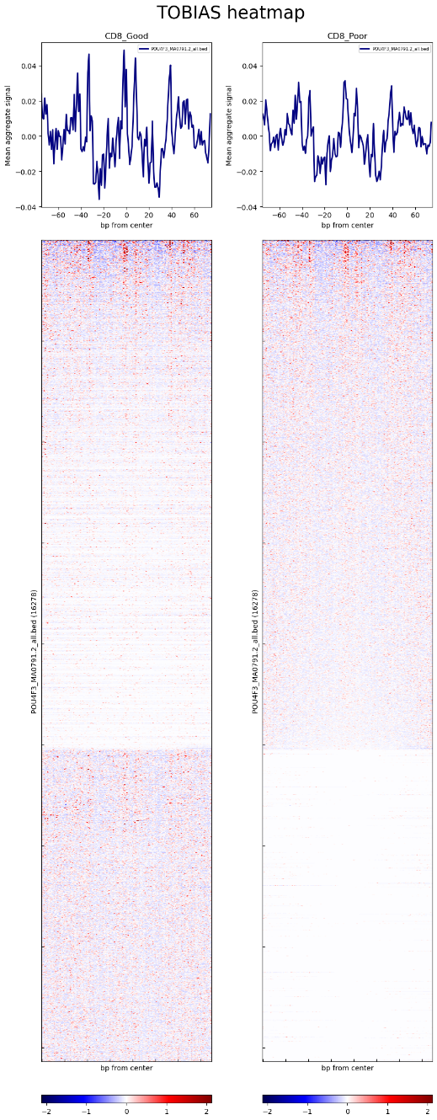Heatmaps

Step 5 – Data Preparation and Differential Analysis (R Studio; DiffBind)

Sample metadata sheets for each experiment (Sample_Sheet_CD4.csv and Sample_Sheet_CD8.csv) were created from the aligned and filtered BAM files and MACS2 peak files. These sheets served as inputs for the dba function to compare the Good and Poor groups within each experiment. The analysis included the execution of dba.blacklist, dba.count, and dba.normalize functions, employing TMM normalization. Differential analysis was carried out using dba.contrast to compare Good and Poor groups for both CD4 and CD8 datasets, followed by dba.analyze using the EdgeR method to identify differentially bound sites (DBS).

Sample correlations were visualized using a heatmap generated by dba.plotHeatmap. Principal component analysis (PCA) was performed with dba.plotPCA, using the parameters DBA_CONDITION and label=DBA_ID. Differential Binding Sites (DBS) were analyzed with dba.report, focusing on p-values due to the limited number of sites with FDR < 0.01. A threshold of 0.05 was applied for significant DBS, while a threshold of 1 was used for all DBS, regardless of significance. Gene names corresponding to the start and end positions of each DBS were included.

Volcano plots were created from the comprehensive DBS dataset, defining significant genes as those with p-values < 0.05 and logFC > -log(0.7) or < log(0.7). Genes with -log10(p-value) > 5 were capped at y = 5 on the plot. The top ten most significant genes were annotated on the volcano plot.

Pathway enrichment analysis was conducted using the fgsea [10] package in R. The gene list comprised all genes identified as DBS. The C7 immunologic signature gene sets from MSigDB (c7.all.v2023.2.Hs.symbols.gmt) were used as the pathway database, with parameters set to minSize = 15, maxSize = 1000, and eps = 0. Results were categorized into CD4 and CD8-related pathways, with non-relevant pathways manually excluded. Each pathway subset was sorted by normalized enrichment score (NES), and the top 30 pathways were classified as up-regulated or down-regulated based on NES sign. A point plot was generated to display the top 30 pathways, with point size representing the number of genes within each pathway.

Results

CD4 Experiment – Good vs Poor

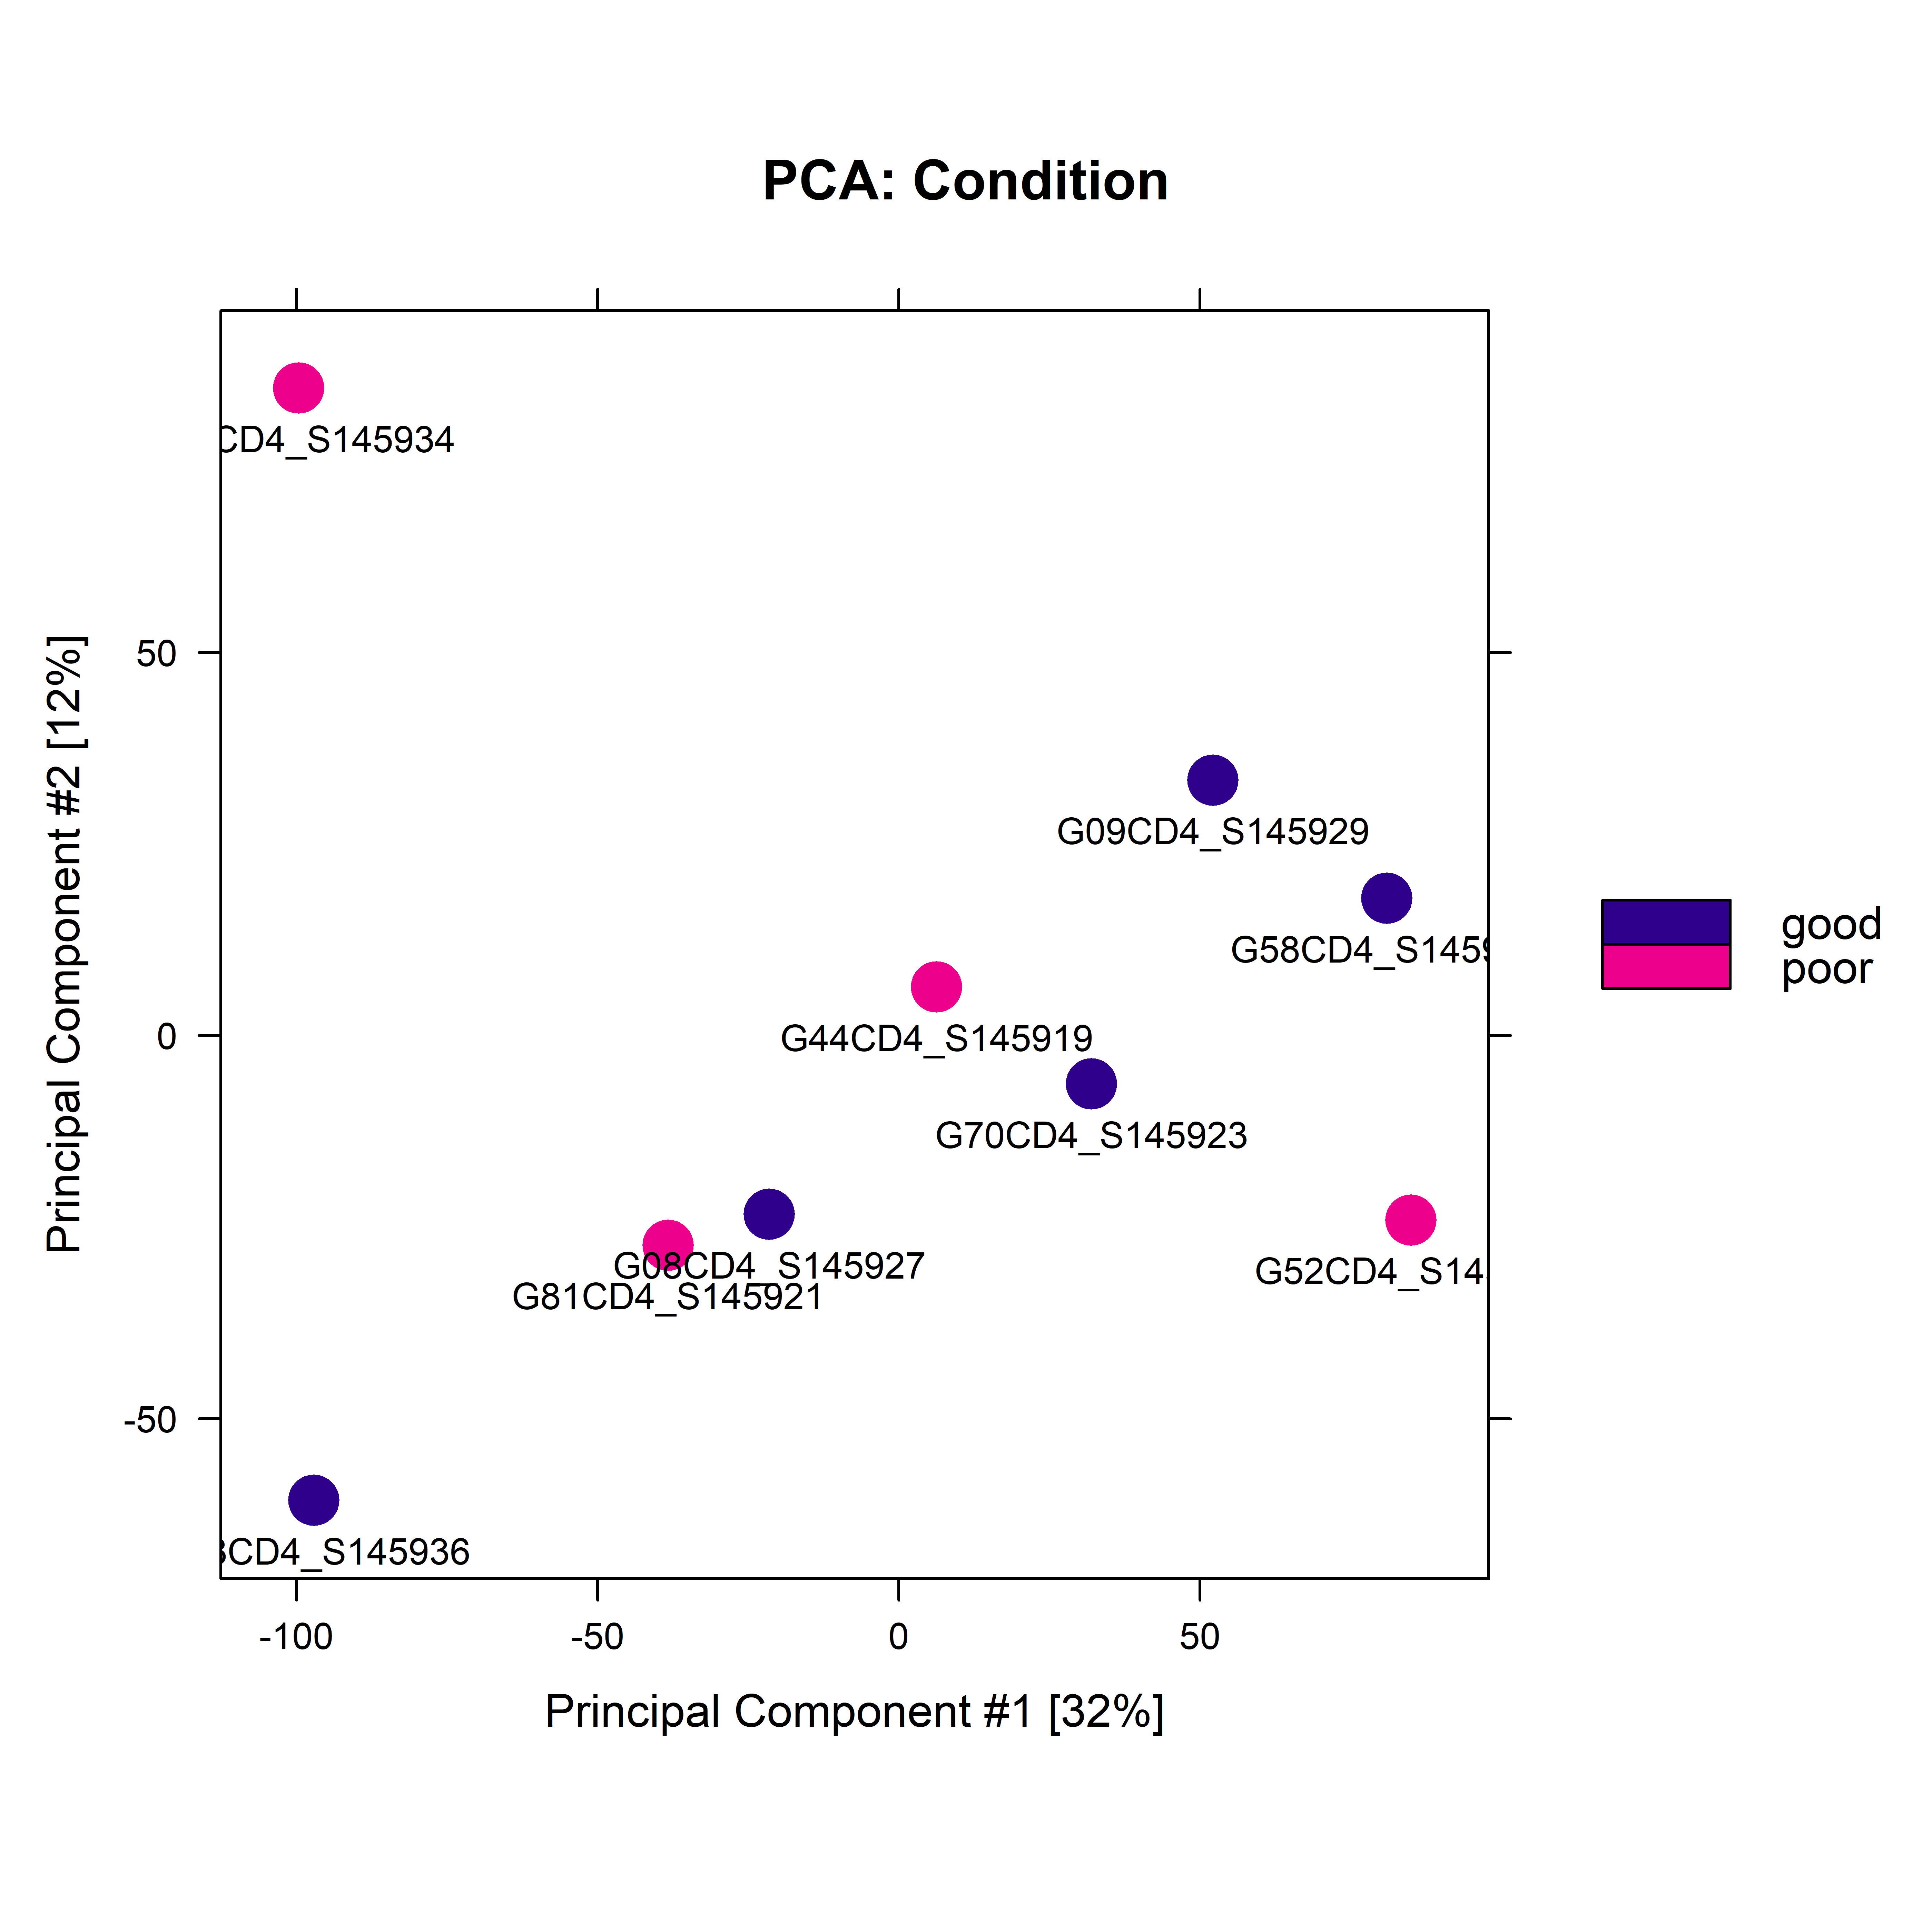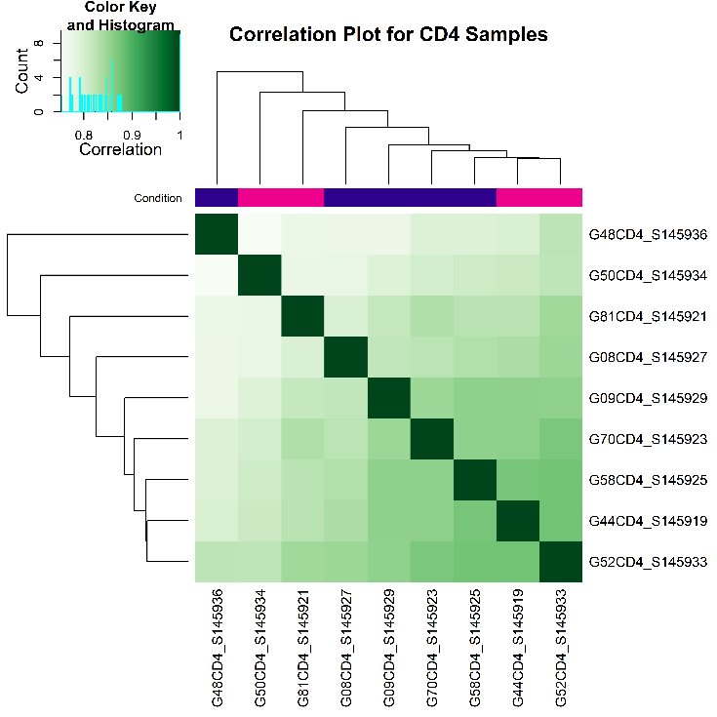Correlation heatmap plot and PCA plot:

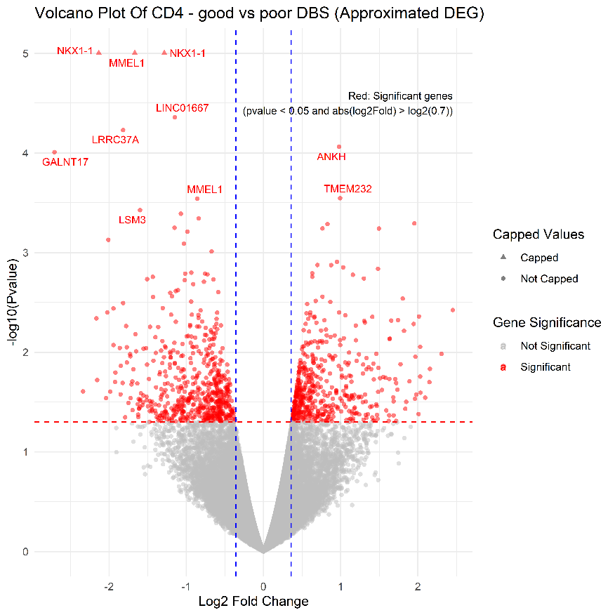Volcano plot:

GSEA plots:

* CD4 related pathways:



* CD8 related pathways:



CD8 Experiment – Good vs Poor

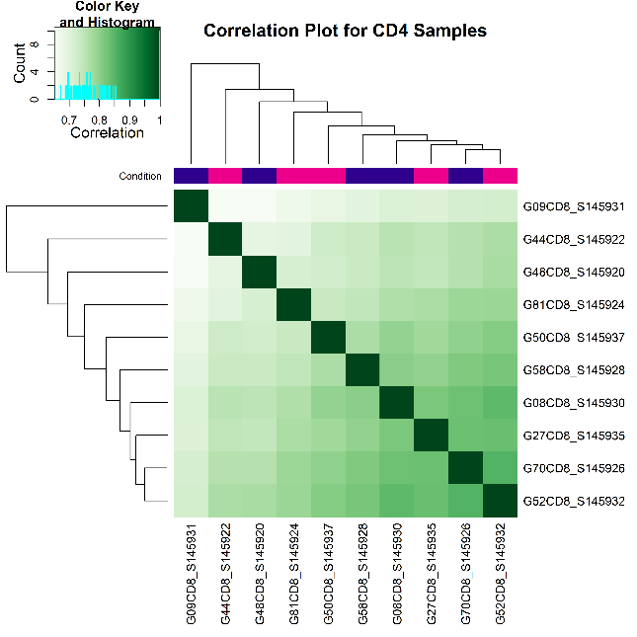Correlation heatmap plot and PCA plot:

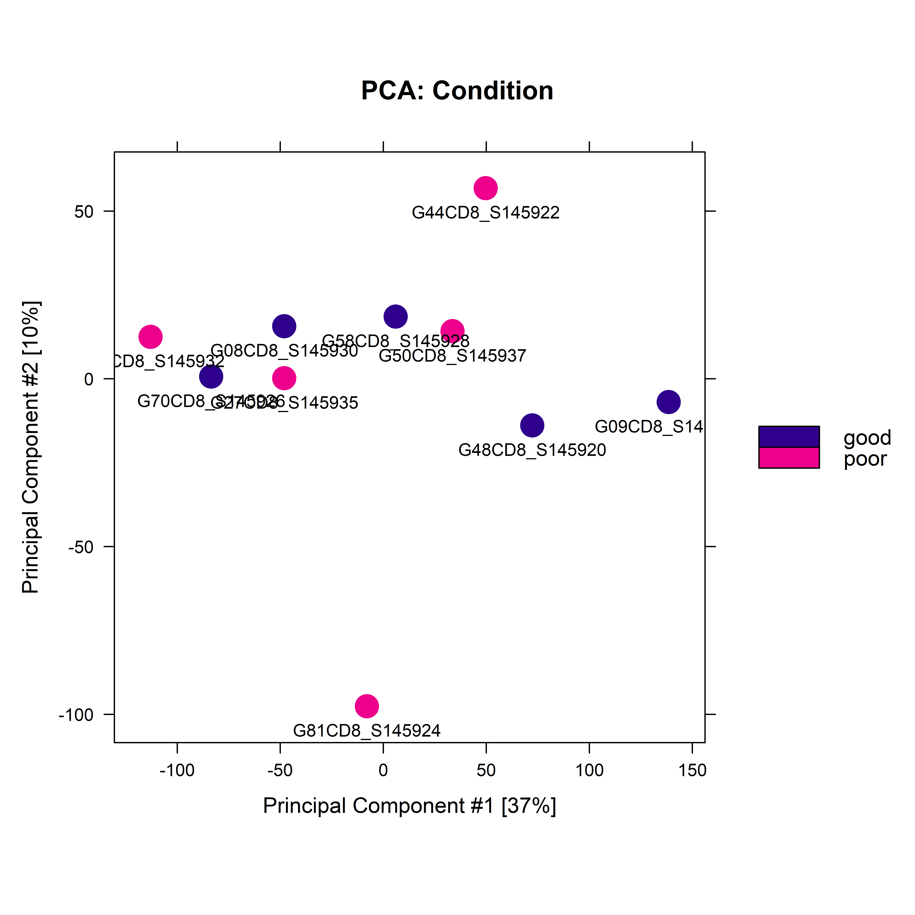

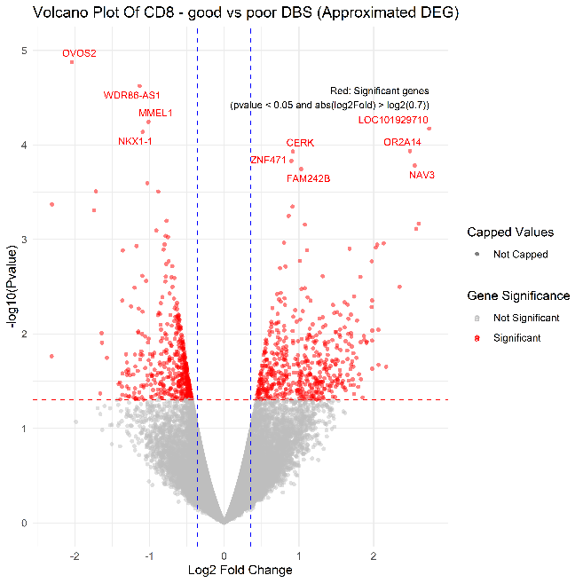Volcano plot:

GSEA plots:

* CD4 related pathways:



* CD8 related pathways:



# References

1. Andrews, S. (2010). FastQC: A Quality Control Tool for High Throughput Sequence Data. [Online] Available at: http://www.bioinformatics.babraham.ac.uk/projects/fastqc/
2. Bolger, A. M., Lohse, M., & Usadel, B. (2014). Trimmomatic: a flexible trimmer for Illumina sequence data. Bioinformatics, 30(15), 2114-2120. doi:10.1093/bioinformatics/btu170
3. Bushnell, B. (2014). BBMap: A Fast, Accurate, Splice-Aware Aligner. [Online] Available at: https://sourceforge.net/projects/bbmap/
4. Li, H. (2013). Aligning sequence reads, clone sequences and assembly contigs with BWA-MEM. arXiv:1303.3997v2 [q-bio.GN]
5. Ramírez, F., Dündar, F., Diehl, S., Grüning, B. A., & Manke, T. (2014). deepTools: a flexible platform for exploring deep-sequencing data. Nucleic Acids Research, 42(W1), W187-W191. doi:10.1093/nar/gku365
6. Zhang, Y., Liu, T., Meyer, C. A., Eeckhoute, J., Johnson, D. S., Bernstein, B. E., ... & Liu, X. S. (2008). Model-based analysis of ChIP-Seq (MACS). Genome Biology, 9(9), R137. doi:10.1186/gb-2008-9-9-r137
7. Bentsen, M., Goymann, P., Schultheis, H., Klee, K., Petrova, A., Wiegandt, R., ... & Theis, F. J. (2020). ATAC-seq footprinting unravels kinetics of transcription factor binding during zygotic genome activation. Nature Communications, 11(1), 4267. doi:10.1038/s41467-020-18035-1
8. Rauluseviciute I, Riudavets-Puig R, Blanc-Mathieu R, Castro-Mondragon JA, Ferenc K, Kumar V, Lemma RB, Lucas J, Chèneby J, Baranasic D, Khan A, Fornes O, Gundersen S, Johansen M, Hovig E, Lenhard B, Sandelin A, Wasserman WW, Parcy F, Mathelier A **JASPAR 2024: 20th anniversary of the open-access database of transcription factor binding profiles** *Nucleic Acids Res.* in_press; doi: [10.1093/nar/gkad1059](https://doi.org/10.1093/nar/gkad1059)
9. Stark R and Brown G (2011). DiffBind: differential binding analysis of ChIP-Seq peak data. Bioconductor http://bioconductor.org/packages/release/bioc/vignettes/DiffBind/inst/doc/DiffBind.pdfRoss-Innes, C. S., Stark, R., Teschendorff, A. E., Holmes, K. A., Ali, H. R., Dunning, M. J.,Brown, G. D., Gojis, O., Ellis, I. O., Green, A. R., Ali, S., Chin, S.-F., Palmieri, C., Caldas, C., and Carroll, J. S. (2012). Differential oestrogen receptor binding is associated with clinical outcome in breast cancer. Nature 481, 389-393.
10. G. Korotkevich, V. Sukhov, A. Sergushichev. Fast gene set enrichment analysis. bioRxiv (2019), doi:10.1101/060012
11. Twelve years of SAMtools and BCFtools

Petr Danecek, James K Bonfield, Jennifer Liddle, John Marshall, Valeriu Ohan, Martin O Pollard, Andrew Whitwham, Thomas Keane, Shane A McCarthy, Robert M Davies, Heng Li

GigaScience, Volume 10, Issue 2, February 2021, giab008, <https://doi.org/10.1093/gigascience/giab008>